Experiment:
With firmware version 1.7.3 on the mbient sensor, we repeated the tests done previously to ascertain which axis (x or y) corresponds to the pitch and roll as produced by the sensor’s Euler angles and by the Euler angles calculated from the Quaternions. We used the MetaBase app and collected Euler angles and Quaternions simultaneously.
We used the same python code to calculate Euler angles from Quaternions as before:
########################################################
def quaternion_to_euler_angle_vectorized1(w, x, y, z):
ysqr = y * y

t0 = +2.0 * (w * x + y * z)
t1 = +1.0 - 2.0 * (x * x + ysqr)
X = np.degrees(np.arctan2(t0, t1))

t2 = +2.0 * (w * y - z * x)
t2 = np.where(t2>+1.0,+1.0,t2)
# t2 = +1.0 if t2 > +1.0 else t2

t2 = np.where(t2<-1.0, -1.0, t2)
# t2 = -1.0 if t2 < -1.0 else t2
Y = np.degrees(np.arcsin(t2))

t3 = +2.0 * (w * z + x * y)
t4 = +1.0 - 2.0 * (ysqr + z * z)
Z = np.degrees(np.arctan2(t3, t4))

return X, Y, Z # roll, pitch & yaw
#########################################################

First, we rotated the sensor about its x – axis. Figure 1 (a) shows the Quaternions: Clearly the Quaternion qx shows that rotation was performed around the x – axis of the sensor. Next, we calculated the Euler angles corresponding to these quaternions and plotted them in Figure 1 (b) (please note the y – axis scales in degrees). We observe that ROLL as produced by the sensor’s Euler angles and ROLL as calculated from the sensor’s Quaternions now correspond with one another (whereas previously they did not).
Second, we rotated the sensor about its y – axis. Figure 2 (a) shows the Quaternions: Clearly the Quaternion qy shows that rotation was performed around the y – axis of the sensor. Next, we calculated the Euler angles corresponding to these quaternions and plotted them in Figure 2 (b) (please note the y – axis scales in degrees). We observe that PITCH as produced by the sensor’s Euler angles and PITCH as calculated from the sensor’s Quaternions now correspond with one another (whereas previously they did not).
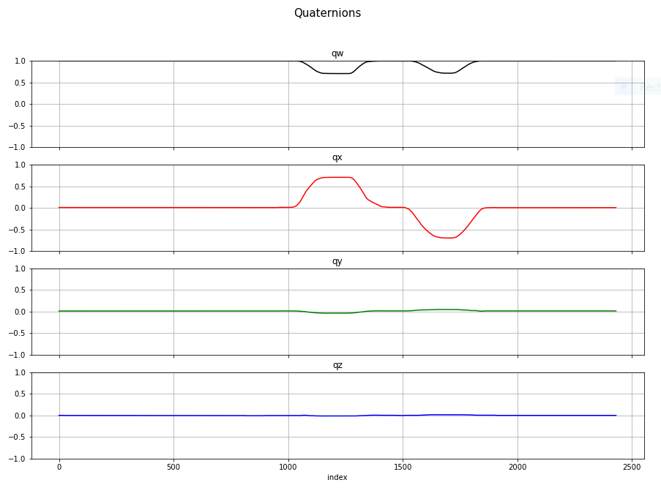
Figure 1 (a)
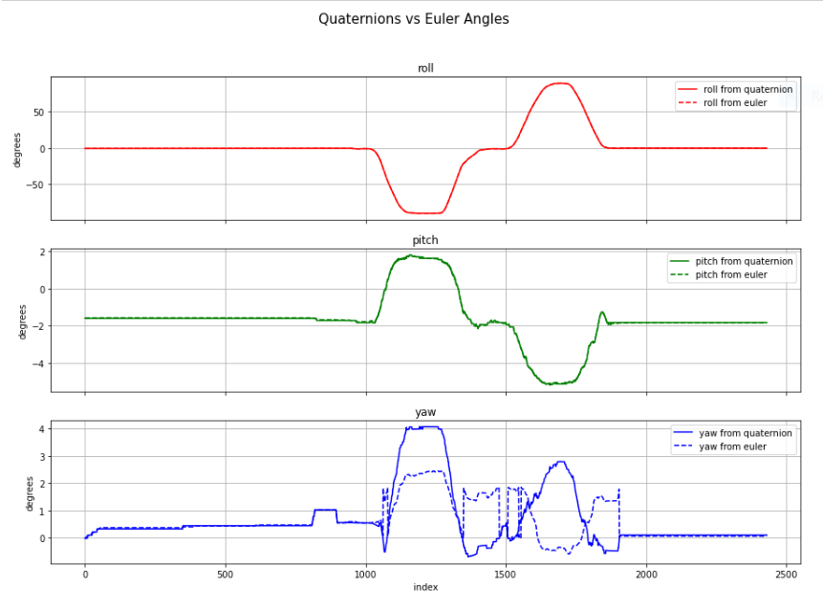
Figure 1 (b)

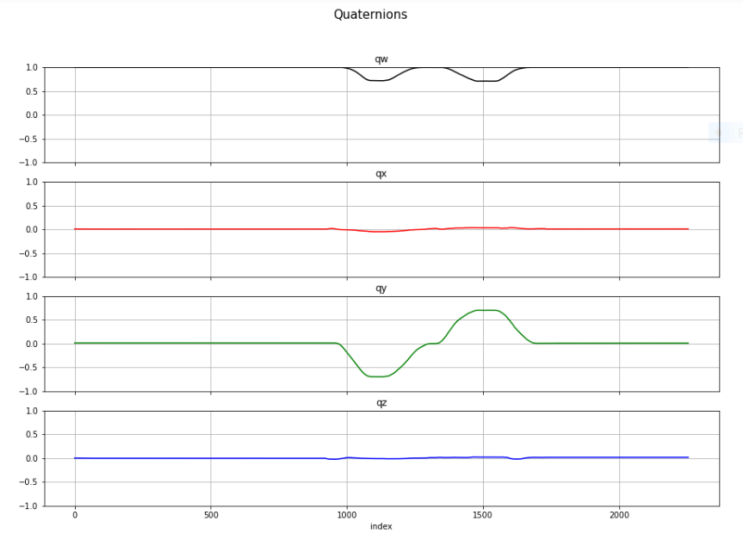
Figure 2 (a)
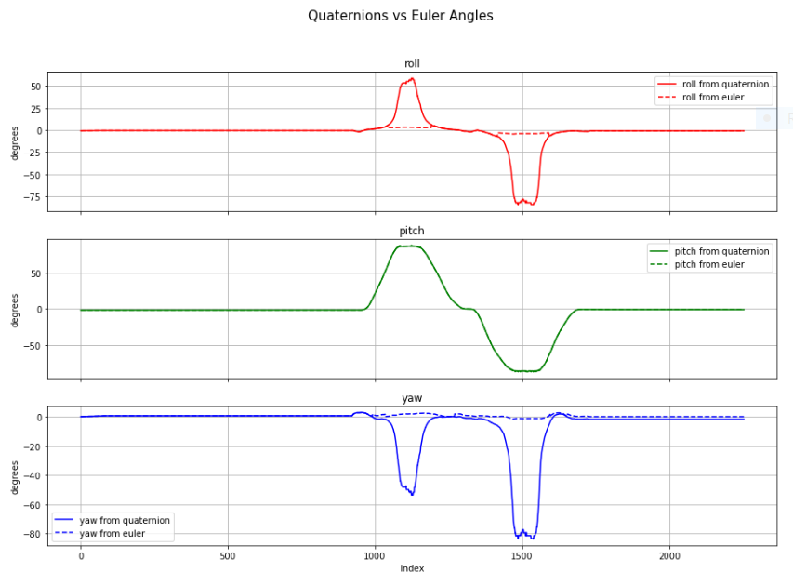
Figure 2 (b)
QUESTION
Previously, Euler angle, PITCH corresponded with Euler angle calculated from Quaternions, ROLL and Euler angle, ROLL corresponded with Euler angle calculated from Quaternions PITCH.
Now, when the only variable that has changed is upgrading the sensor firmware to ver. 1.7.3, Euler angle, ROLL corresponds with Euler angle calculated from Quaternions, ROLL when rotating the sensor about its x – axis, and Euler angle PITCH corresponds with Euler angle calculated from Quaternions PITCH when rotating the sensor about its y – axis.
- Could you please explain the discrepancy between these results and our previously posted results?
- Furthermore, in Figure 2 (b), which sensor readings am I to use; Euler angles OR Euler angles calculated from Quaternions?

